EMPLOYEE MANAGEMENT SYSTEM
ABSTRACT

Employee management System is a distributed application, developed to maintain the details of employees working in any organization. It maintains the information about the personal details of their employees, also the details about the payroll system which enable to generate the pay slip. The application is actually a suite of applications developed using Java. This software package has been developed using the powerful coding tools of JAVA at Front End and Microsoft Sql Server at Back End. The software is very user friendly. The package contains different modules like Employee details. Employee management system is an application that enables users to create and store Employee Records. The application also provides facilities of a payroll system which enables user to generate Pay slips too. This application is helpful to department of the organization which maintains data of employees related to an organization.

SYSTEM SPECIFICATION
HARDWARE SPECFICATION:
- Processor : P 4 700 GHz.
- RAM : 4 GB RAM
- Hard Disk Drive : 180 GB

SOFTWARE SPECIFICATION:

  - Operating System : Windows 7/8/10
  - Front End : JAVA
  - Back End : SQL
Existing System
In this existing system very hard to managing the employees manually. Sometimes it has taken more to search one particular employees. This will take too much time to find one employee.
Disadvantages:
- It takes too much time to find employee
- Can’t handle employee working hours
- We can’t track the employee
- Wasting paper-based period
Proposed System
This system will be overcome these kinds of issue, which makes to find and employees details at any time. We can track the employee immediately. We can easily find the employee working hours also which may help to find the employee who are taken leave on that day.
Advantages:
- Tracking employees’ details
- Attractive interface
- Everyone can using this software.
- Low cost and high benefit

Modules
- Login Module
- Employee Registration
- Salary management module
- Leave type entry
- Leave Module

Login Module
Admin and employee both can login this portal. Every user has own credential. Which make secure to display the details. Users can’t see others users’ details.

Employee Registration
This module has to use to collect the employee information and save into the database. Once the employee registration has been completed, they will get username and password, when need to login just use this credential to move login page.

Salary Management Module
Salary management module is used managing the salary details for employees. Admin can manage all the employee’s salary details. Every month we can generate the pay slip by admin.

Leave Type Entry:
This module has been created by manager, this will in casual leave, marriage leave, sick leave or anything. The employee can choose the leave type and sending leave request to the manager.
Leave Module:
Employee should send the leave request before taking a leave. The request was accepting by administrator. If the administrator does not accept the leave request employee can’t to take a leave. So, manager can find who are all taking a leave on today.

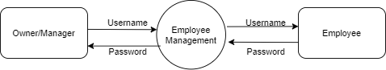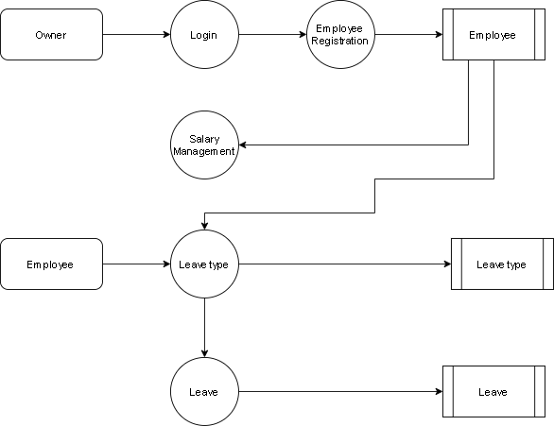

TABLE NAME: MANAGER
FIELD | DATA TYPE | SIZE | CONSTRAINT
Manager id | Int | 10 | Primary key
Username | Varchar | 20 | Not null
password | Varchar | 20 | Not null

TABLE NAME: EMPLOYEES
FIELD | DATA TYPE | SIZE | CONSTRAINT
Employee id | Int | 10 | Primary key
First name | Varchar | 20 | Not null
Last name | Varchar | 20 | Not null
Email | Varchar | 20 | Not null
Password | Varchar | 20 | Not null
Gender | Varchar | 10 | Not null
City | Varchar | 10 | Not null
Country | Varchar | 10 | Not null
address | Varchar | 30 | Not null
Phone number | Int | 10 | Not null

TABLE NAME: LEAVE TYPE
FIELD | DATA TYPE | SIZE | CONSTRAINT
Type id | Int | 10 | Primary key
Leave name | Varchar | 20 | Not null
Leave category | Varchar | 20 | Not null

TABLE NAME: LEAVE
FIELD | DATA TYPE | SIZE | CONSTRAINT
Leave id | Int | 10 | Primary key
Leave type | Varchar | 20 | Not null
From date | Date | 10 | Not null
To date | Date | 10 | Not null
Description | Varchar | 30 | Not null

TABLE NAME: LEAVE APPROVE
FIELD | DATA TYPE | SIZE | CONSTRAINT
Leave id | Int | 10 | Primary key
Employee id | Int | 10 | Foreign key
From date | Date | 10 | Not null
To date | Date | 10 | Not null
Leave status | Varchar | 10 | Not null

